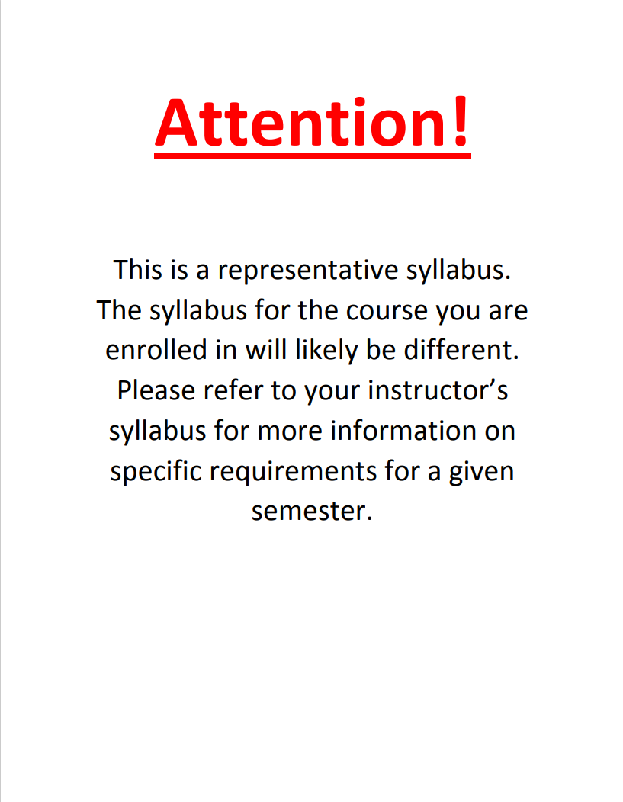

Interdisciplinary Approaches to South Asia
SASIA 5241
Instructor:
Instructor email:
Instructor’s office:
Office Hours:
Course website: www.Canvas.osu.edu
Instructor's Mailbox:
Course Description
This course is designed (for students in any field) as a multi-disciplinary introduction to South Asia, primarily focusing on India, Pakistan, Bangladesh, Sri Lanka, Nepal, and Bhutan, but also referring to Afghanistan, Tibet, and Maldives in geographical, political, cultural, and religious context and connections. The course presents an overview of research methods to study South Asian and its international relations, and its role in the global economy. The course also introduces students to the diversity of South Asian culture, including South Asian religions, society, art, literature, and cinema.
Required texts
- Emerson, Robert, Rachael Fretz and Linda Shaw (2011). Writing Ethnographic Fieldnotes. University of Chicago Press.
- Cohen, Lawrence (1999). No Aging in India: Alzheimer's, the Bad Family and Other Modern Thing. University of California Press.
- Geertz, Clifford (1973). The Interpretation of Cultures. New York: Basic Books.
- Gayatri, Reddy (2005). With Respect to Sex. University of Chicago Press
Suggested reading
- Chatterjee, Partha (2006). The Politics of the Governed. Columbia University Press.
- Clark, Deces (2011). A companion to the anthropology of India. Wiley Blackwell.
- Schwarz, Henry (1997). Writing Cultural History in Colonial and Postcolonial India. University of Pennsylvania Press.
Readings of interest for student final projects

- Dhingra, Pawan (2012). Life behind the Lobby: Indian American Motel Owners and the American Dream. Stanford University Press.
- Lamb, Sarah (2009). Aging and the Indian Diaspora: Cosmopolitan Families in India and Abroad. Indiana University Press.
- Sandhya, Shukla (2003). India Abroad: Diasporic Cultures of Postwar America and England. Princeton University Press.
- Shankar, Shalini (2008). Desi Land: Teen Culture, Class, and Success in Silicon Valley. Duke University Press.

Where required texts are available
The required texts can be bought online. Chapters from various books and journal articles will be made available on Canvas.
Assignment format and schedule
Weekly summary of readings 50% of total grade
Students will be required to write a summary for readings each week. The summaries should be 500-1000 words long and should present the main arguments of the reading in a cohesive manner. The goal of the summaries will be to ensure that students get the point of the readings and also develop their writing skills.
Weekly discussion questions 25% of total grade
I will teach this class like a seminar. This will mean we will not have lectures and class will be guided by student discussion questions. Every student will bring two questions per class period based on the readings for the day. The questions should provide grounds for a critique of the arguments that the reading is presenting and should pave ground for further discussion. Bring a typed copy of your questions to class every class period. The questions will be circulated among all students so everyone can respond to your questions.
Final paper project 25% of total grade
The final paper will be a two-part project involving an abstract submission and a final paper. The final paper should be 7-10 pages and should be a discussion of two-three themes from this class and how these themes connect to your own research projects.
Abstract for final paper 5% of total grade due on 3/9
Final paper 20% of final grade due on 4/28

Grading scale
Grading scale: A (93-100) A- (90-92) B+ (87-89) B (83-86) B- (80-82) C+ (77-79) C (73-76) C- (70-72) D+ (67-69) D (60-66) E (below 60)
Attendance policy
If you miss more than one in the course of the semester for any reasons other than medical or family emergencies (for which you can provide written proof), your grade will go down one letter.
Weekly schedule
Topic: Understanding ethnography
Week 1
Hammersley, Martyn and Paul Atkinson (2001). Ethnography: Principles in Practice. Chapter 1,2,3
Week 2
Strathern, Marilyn (1991) Partial Connections. Rowman and Littlefiled Publishers, 1-55.
Oldenberg, Veena Talwar (2002) Dowry Murder: The imperial origins of a cultural crime. Oxford University Press. 1-39
Diaspora
Week 3, Week 4
Diaspora
Prashad, Vijay (2007) The Karma of Brown Folk
Week 5: Politics
Witsoe, Jeffrey (2009).Territorial Democracy: Caste, Dominance and Electoral Practice in Postcolonial India. In Political and Legal Anthropology Review. 32 (1). 64-83.*

Week 6-7 Family
Required text: No Aging in India
Week 8 Gender
Sunder-Rajan, Rajeshwari (2003). The scandal of the State. Duke University Press. 1-40, 147-212.*
Mehta, Rama (1975). Divorced Hindu Women. Vikas Publishing House. 1-119.*
Week 9 Gender
Spivak, Gayatri Chakravorty (1988). In Other Worlds: Essays in Cultural Politics. Routledge: New York and London. 179-269*
Week 10 Sexuality
Required texts: With Respect to Sex. Chapters 1-3
Week 11 Caste and class
Ray, Raka and Seemin Qayum (2009). Cultures of Servitude: Modernity, Domesticity and Class in India. Stanford University Press. 1-65, 145-167.*
Dirks, Nicholas (2001). Castes of Mind: Colonialism and the making of Modern India. Princeton University Press. 1-61, 125-198, 255-297.*
Week 12: Religion
Hansen, Thomas Blom (1999). The Saffron Wave. Democracy and Hindu Nationalism in Modern India, Princeton University Press. 1-90.
Week 13 Review
Week 14: The new economy and the environment
Baviskar, Amita (2004). In the Belly of the River. Oxford University Press, Delhi.
Week 15: From rural to urban: The face of new India
Roy, Ananya and Ahiwa Ong (2011). Wordling Cities: Asian Experiments and the Art of Being Global. Wiley Blackwell. 259-336.*
Concluding remarks and tying loose ends together
Week 16 Final project due
*Will be posted on Canvas
Academic Misconduct - It is the responsibility of the Committee on Academic Misconduct to investigate or establish procedures for the investigation of all reported cases of student academic misconduct. The term “academic misconduct” includes all forms of student academic misconduct wherever committed; illustrated by, but not limited to, cases of plagiarism and dishonest practices in connection with examinations. Instructors shall report all instances of alleged academic misconduct to the committee (Faculty Rule 3335-5-487). For additional information, see the Code of Student Conduct http://studentlife.osu.edu/csc/.

Disabilities Policy - The University strives to make all learning experiences as accessible as possible. If you anticipate or experience academic barriers based on your disability (including mental health, chronic or temporary medical conditions), please let me know immediately so that we can privately discuss options. To establish reasonable accommodations, I may request that you register with Student Life Disability Services. After registration, make arrangements with me as soon as possible to discuss your accommodations so that they may be implemented in a timely fashion. SLDS contact information: slds@osu.edu; 614-292-3307; slds.osu.edu; 098 Baker Hall, 113 W. 12th Avenue.
Assignment schedule
Week | Reading summary due | Discussion question due | Other deadlines
2 | January 19th | January 19th
3 | January 26th | January 26th
4 | February 2nd | February 2nd
5 | February 9th | February 9th
6 | February 16th | February 16th
7 | February 23rd | February 23rd
8 | March 2nd | March 2nd
9 | March 9th | March 9th | Abstract due
11 | March 23rd | March 23rd
12 | March 30th | March 30th
13 | April 6th | April 6th
14 | April 13th | April 13th
15 | April 20th | April 20th
 |  |  | April 28th

