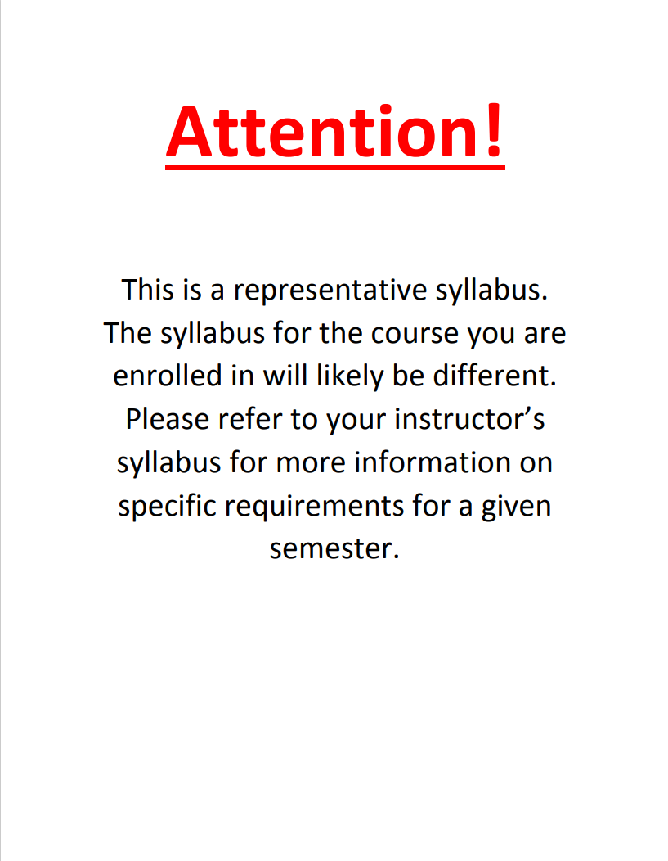Syllabus

Arabic / WGSS 2702
Gender and Citizenship in Modern Arabic Literature
3 credits
Meeting days and times: TBD
Instructor: TBD
Office hours: TBD
Prerequisites: completion of GE Foundation Writing and Information Literacy course
This course explores modern Arabic literature from the 1960s to the present as a space where different understandings of gender and citizenship are analyzed and imagined. Starting with debates about gender and citizenship in the early postcolonial period, we will discuss novels, short stories, and poetry by women writers that speak to different historical and national contexts, such as liberation from colonial powers, the Lebanese Civil War, Palestinian historical memory, and legacies of slavery in the Gulf. We will complement these literary texts with both documentary and narrative film. In each section of the class, we will consider how literary texts intervene in different conceptions of citizenship and social justice. By participating in ongoing scholarly conversations on modern Arabic literature and gender we will also reflect on how our own learning community is generating questions and knowledge.

Course goals:
By the end of this course, students should successfully be able to:
- Read and analyze modern Arabic literary texts in translation in their social, national, and political contexts
- Demonstrate familiarity with major themes and debates in postcolonial Arabic literature written by women authors
- Analyze a variety of ways that gender is explored in Arabic literature, through means such as language and narrative structure
- Consider how constructions of citizenship are often explicitly and implicitly gendered
- Probing the relationship between being attentive readers of global literature and developing competency as a global citizen
- Discuss how citizenship (and sometimes efforts to re-define it) is implicated in projects to advance justice for diverse populations
- Identify and examine their own implicit beliefs about social identities, including gender, ethnicity, and race

General Education
Foundations: Citizenship for a Just and Diverse World

Goals and ELOs
Goal 1: Successful students will analyze concepts of citizenship, justice and diversity at a more advanced and in-depth level than in the Foundations component.
1.1 Engage in critical and logical thinking about the topic or idea of citizenship for a just and diverse world.
1.2 Engage in an advanced, in-depth, scholarly exploration of the topic or idea of citizenship for a just and diverse world.
Goal 2: Successful students will integrate approaches to understanding citizenship for a just and diverse world by making connections to out-of-classroom experiences with academic knowledge or across disciplines and/or to work they have done in previous classes and that they anticipate doing in future.
2.1 Identify, describe and synthesize approaches or experiences as they apply to citizenship for a just and diverse world.
2.2 Demonstrate a developing sense of self as a learner through reflection, self-assessment and creative work, building on prior experiences to respond to new and challenging contexts.
Goal 3: Successful students will explore and analyze a range of perspectives on local, national or global citizenship and apply the knowledge, skills and dispositions that constitute citizenship.
3.1 Describe and analyze a range of perspectives on what constitutes citizenship and how it differs across political, cultural, national, global and/or historical communities.
3.2 Identify, reflect on and apply the knowledge, skills and dispositions required for intercultural competence as a global citizen.

Goal 4: Successful students will examine notions of justice amid difference and analyze and critique how these interact with historically and socially constructed ideas of citizenship and membership within society, both within the United States and around the world.
4.1 Examine, critique and evaluate various expressions and implications of diversity, equity and inclusion, and explore a variety of lived experiences.
4.2 Analyze and critique the intersection of concepts of justice, difference, citizenship, and how these interact with cultural traditions, structures of power and/or advocacy for social change.

In this course, we will meet these goals by:

- examining how gender is constructed in literary texts.

- discussing the way that important frameworks and contexts of modern Arabic literature such as Orientalism, nationalism, and diaspora are understood in relation to gender.

- focusing on the role that historical and social contexts have played in shaping the form, style, and themes of literary works.

- analyzing how meaning is constructed through literary devices and aesthetics.

- appreciating the different ways that Arabic literature has engaged with social issues in modern and contemporary societies.

- examining our own implicit and explicit beliefs about gender in a variety of contexts.

- Engaging with our classroom community in a manner that supports each individual’s learning and dignity.

Required books
Books to purchase or access through the library:
- The Open Door by Latifa al-Zayyat, ISBN-13: 9789774168277
- The Stone of Laughter by Hoda Barakat, ISBN-13: 9781566561907
- Minor Detail by Adania Shibli ISBN-13: 978-0811229074
- Celestial Bodies by Jokha Alharthi ISBN-13: 978-1948226943

You can order the books as a packet from Columbus Bookspace: https://bookspacecolumbus.com/collections/shop-all
If ordering from elsewhere use the ISBN number to make sure you are reading the same edition as others in the class.
Two out of the four books are available as ebooks through OSU Libraries:
The Open Door: https://library.ohio-state.edu/record=b8913301~S7
Celestial Bodies: https://library.ohio-state.edu/record=b8940799~S7

All other reading and viewing materials will be made available on Carmen.

*Knowledge of Arabic is not a requirement for this course. However, for those of you who read Arabic and would like to consult the original texts, you will find PDFs of the Arabic originals on Canvas.

How your grade is calculated
Assignment category | Percentage
Class participation | 15
Weekly Assignments | 15
Scaffolded Research and Writing Assignments (4x10%) | 40
Final project proposal | 5
Final project (Short Research Paper or Creative Project) 30% | 25
Total | 100
See course schedule below for due dates.

Descriptions of major course assignments
Participation (15%) Participation is an important component of the learning process. It helps you activate your knowledge and process course materials and discussions. Participation may mean different things to different learners. In this course, participation includes contributing to group discussions, listening and responding to the instructor and peers, speaking in class discussions, and reflecting on ideas through in-class writing assignments.
Regular attendance is essential for your success in this course and for building a consistent learning community. After three absences your final grade will be lowered by 3%. Please speak to the instructor if you are in an extended situation that prevents you from attending class. Please stay home if you are feeling ill and communicate with the instructor on how you can catch up!
Academic integrity and collaboration: You are encouraged to collaborate with your peers during our synchronous Zoom discussions.

Weekly Assignments (15%) Most weeks, students will complete an assignment that engages course materials in different ways. We will use a variety of formats, for example, participation in discussion board, short written reflections on readings, formulating questions, taking quizzes, and creative work. In some cases, students will complete weekly assignments in designated small groups.
Academic integrity and collaboration: For the group assignments, students are required to collaborate. In some cases (such as quizzes) students will only submit their own work.

Scaffolded Research and Writing Assignment (40%) Four short (2-page) writing assignment will each focus on a particular writing and research skill including using textual evidence, engaging with secondary sources, creative writing, and analyzing character and narrative structure. Each writing assignment focuses on the content of a particular novel and section of the course. These assignments aim to deepen your engagement with course materials and prepare you for the final project.
Textual evidence (10 %) In this assignment you will use textual evidence (cite, paraphrase) from The Open Door to support a thesis about how the book engages with concepts of justice in the early postcolonial periods.
Creative writing (10 %). In this assignment you will write a creative, fictional, personal, and / or experimental text inspired by The Stone of Laughter and the novel’s exploration of difference in the context of a nation at war.

Scholarship as conversation (10% ) In this assignment you will engage with a secondary source (documentary, article, or chapter discussed in class) to analyze the novel Minor Detail.
Presentation on racial justice initiatives in the Middle East (10%) In this group assignment, your group will select a source or initiative on racial justice in the Middle East (list provided) and prepare a concise presentation that summarizes key points and applies them to the novel Celestial Bodies and / or other course materials.
Academic integrity and collaboration: Students may consult with the instructor, TA, or Middle East Studies Librarian.

Final Project Proposal: (5%) A few weeks before the final project is due you will submit an outline of your proposed plans for feedback.

Final Project (25%) Your final project is a short research paper (around 5-6 double-spaced pages) where you support and argument using textual evidence from semester readings. You will also engage with context and secondary academic sources. This is a chance to put together the skills you have been practicing!
There is also a creative option. You may write a short story, creating a film, podcast, write poetry, etc. or do something else related to the topics of the class. A creative project will include a short written reflection (about 2 double-spaced pages) on the process and the goals for your work.
Academic integrity and collaboration:
Students may consult with the instructor or Middle East Studies Librarian.

Late assignments: Please talk to your instructor if you believe you will have trouble meeting a deadline.
Grading scale: A (93-100) A- (90-92) B+ (87-89) B (83-86) B- (80-82) C+ (77-79) C (73-76) C- (70-72) D+ (67-69) D (60-66) E (below 60)
Refer to the Carmen course for up-to-date assignment due dates.
Week | Dates | Topics, Readings, Assignments, Deadlines
1 |  | Topic: Introductions to each other and the course  Assignment for day 2:  - Take welcome survey on Carmen  - Read chapters 1-3 in the The Open Door (pp. 1-60) and read:  https://arablit.org/2017/08/03/must-read-classics-by-women-latifa-al-zayyats-the-open-door/
2 |  | Topic: The Open Door / Debates on National Liberation  Assignment for day 1:  - Read chapters 4-8 in The Open Door (pp. 61-137)  - Submit discussion board post + peer response on Canvas  Assignment for day 2:  - Chapters 9-13 in The Open Door (pp. 139-204)
3 |  | Topic: The Open Door / Feminism and Postcolonial Nationalism  Assignment for day 1:  - Read chapters 14-18 in The Open Door (pp. 205-260)  - Watch: Nasser’s Republic: The Making of Modern Egypt (Goldman 2016) https://library.ohio-state.edu/record=b8063050~S7  - Take quiz on film  Assignment for day 2:  - read: Chapters 19-24 in The Open Door (pp. 291-321)
4 |  | Topic: The Open Door / The New Citizen: Individual and Collective Transformation  Assignment for day 1:  - Read chapters 25-30 in The Open Door (pp. 323-360) + "About The Open Door"  - Watch clips of the film The Open Door posted on Canvas  - Post trial run textual evidence assignment for instructor feedback  Assignment for day 2:  - Reflect on The Open Door for Socratic seminar integrative discussion (no submission)  *Textual Evidence assignment due
5 |  | Topic: Literary and Cinematic Movements of the Lebanese Civil War  Assignment for day 1:  - No assignments (in-class lecture)  Assignment for day 2:  - Watch film West Beirut (Douiri 1988)
6 |  | Topic: The Stone of Laughter / Gender, Citizenship, and War  Assignment for day 1:  - Read pp. 1-46 in The Stone of Laughter  Assignment for day 2:  - Before class, read pp. 126-170 in The Stone of Laughter  - Visual representation of Khalil (submit on Canvas)
7 |  | Topic: The Gothic: An Exploration of Collective Anxieties  Assignment for day 1:  - Review concepts of the uncanny, doubling, haunting, liminality, and the other (posted on Canvas)  - Read the story “Beheading the Cat” by Ghada al-Samman  Assignment for day 2:  - Read “The Plot against Badi’” by Ghada al-Samman  - Post annotations on miriam cooke’s chapter “The Role of Myth” from War’s Other Voices (1998)
8 |  | Topic: Poetic Reflections on Death / Socratic Seminar  Assignment for day 1:  - Read “Five Senses for One Death” by Etel Adnan  - Submit trial run creative assignment for feedback  Assignment for day 2:  - Reflect on topics from this section to prepare for Socratic seminar  *Creative writing assignment due
9 |  | Topic: Minor Detail: Writing History and National Trauma  Assignment for day 1:  - No assignments due (in-class lecture on Palestinian literature)  Assignment for day 2:  - read pp. 1-22 in Minor Detail  - post on discussion board
10 |  | Topic: Minor Detail / Language and Power in Palestine  Assignment for day 1:  - read pp. 23-52 in Minor Detail  - Watch Al-Nakba: The Palestinian Catastrophe (Brunner 1996)  Assignment for day 2:  - Read pp. 53-70 in Minor Detail  - Listen to excerpts of interview with Adania Shibli and respond to one idea (post on Carmen)
11 |  | Topic:  Assignment for day 1:  - Read pp. 70-105 in Minor Detail  - Read excerpt of Leila Farsakh's introduction to Re-thinking Statehood in Palestine: Statehood and Decolonization beyond Partition  Assignment for day 2:  - Submit trial run “research as conversation assignment” to Canvas for feedback  - Reflect on section topics for Socratic seminar  *Research as conversation assignment due
12 |  | Topic: Celestial Bodies / Gendered Narratives of Citizenship and History  Assignment for day 1:  - read "Translator's Introduction" + pp. 1-45 in Celestial Bodies  - Groups select topic for racial justice initiatives presentations  Assignment for day 2:  - read pp. 46-90 in Celestial Bodies
13 |  | Topic: Celestial Bodies / Legacies of Slavery  Assignment for day 1:  - read pp. 91-140 in Celestial Bodies  Assignment for day 2:  - read pp. 141-186 in Celestial Bodies  - post reflections on “literature and justice” prompts in Canvas
14 |  | Topic: Global Literature and Citizenship  Assignment for day 1:  - Read pp. 187-243 in Celestial Bodies  - Watch excerpts of panel “Arab Writers Going Global”  Assignment for day 2:  - Turn in proposal for final project
15 |  | Topic: Wrapping up / Course Celebration  Assignment for day1:  - Group Presentations  Assignment for day 2:  - Take a moment to rest!  *Final projects due the day of our scheduled finals slot

Final project due: date TBD
Academic Misconduct:
It is the responsibility of the Committee on Academic Misconduct to investigate or establish procedures for the investigation of all reported cases of student academic misconduct. The term “academic misconduct” includes all forms of student academic misconduct wherever committed; illustrated by, but not limited to, cases of plagiarism and dishonest practices in connection with examinations. Instructors shall report all instances of alleged academic misconduct to the committee (Faculty Rule 3335-5-487). For additional information, see the Code of Student Conduct http://studentlife.osu.edu/csc/.
Disability Services:
The University strives to make all learning experiences as accessible as possible. If you anticipate or experience academic barriers based on your disability (including mental health, chronic or temporary medical conditions), please let me know immediately so that we can privately discuss options. To establish reasonable accommodations, I may request that you register with Student Life Disability Services. After registration, make arrangements with me as soon as possible to discuss your accommodations so that they may be implemented in a timely fashion. SLDS contact information: slds@osu.edu; 614-292-3307; slds.osu.edu; 098 Baker Hall, 113 W. 12th Avenue.
Mental Health:
As a student you may experience a range of issues that can cause barriers to learning, such as strained relationships, increased anxiety, alcohol/drug problems, feeling down, difficulty concentrating and/or lack of motivation. These mental health concerns or stressful events may lead to diminished academic performance or reduce a student’s ability to participate in daily activities. The Ohio State University offers services to assist you with addressing these and other concerns you may be experiencing. If you or someone you know are suffering from any of the aforementioned conditions, you can learn more about the broad range of confidential mental health services available on campus via the Office of Student Life’s Counseling and Consultation Service (CCS) by visiting ccs.osu.edu or calling 614-292-5766. CCS is located on the 4th Floor of the Younkin Success Center and 10th Floor of Lincoln Tower. You can reach an on call counselor when CCS is closed at 614-292-5766 and 24 hour emergency help is also available through the 24/7 National Suicide Prevention Hotline at 1-800-273-TALK or at suicidepreventionlifeline.org.
Sexual misconduct / relationship violence:
Title IX makes it clear that violence and harassment based on sex and gender are Civil Rights offenses subject to the same kinds of accountability and the same kinds of support applied to offenses against other protected categories (e.g., race). If you or someone you know has been sexually harassed or assaulted, you may find the appropriate resources at http://titleix.osu.edu or by contacting the Ohio State Title IX Coordinator at titleix@osu.edu
Diversity:
The Ohio State University affirms the importance and value of diversity in the student body. Our programs and curricula reflect our multicultural society and global economy and seek to provide opportunities for students to learn more about persons who are different from them. We are committed to maintaining a community that recognizes and values the inherent worth and dignity of every person; fosters sensitivity, understanding, and mutual respect among each member of our community; and encourages each individual to strive to reach his or her own potential. Discrimination against any individual based upon protected status, which is defined as age, color, disability, gender identity or expression, national origin, race, religion, sex, sexual orientation, or veteran status, is prohibited.

